AWS  **INTRODUCTION**

A high level introduction of the various a ws services as per their usage in the architecture is presented in the below diagram.

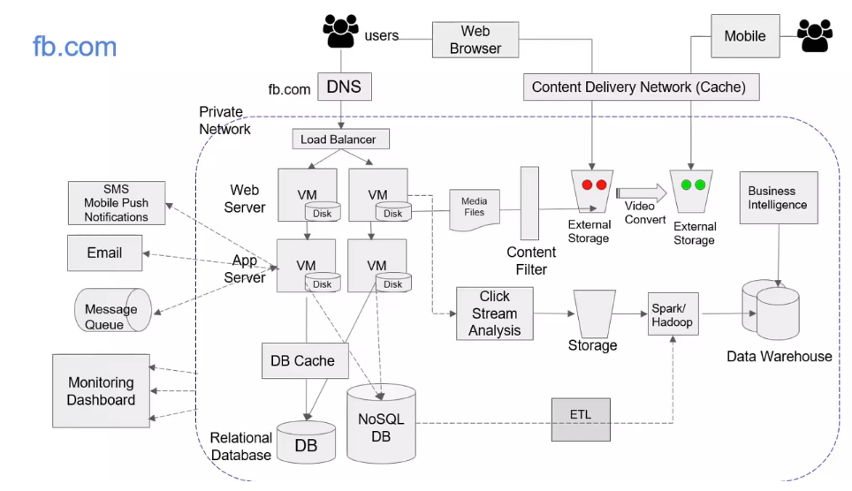

Now we will replace the above with the aws services or how this architecture will fit in using the various aws services. 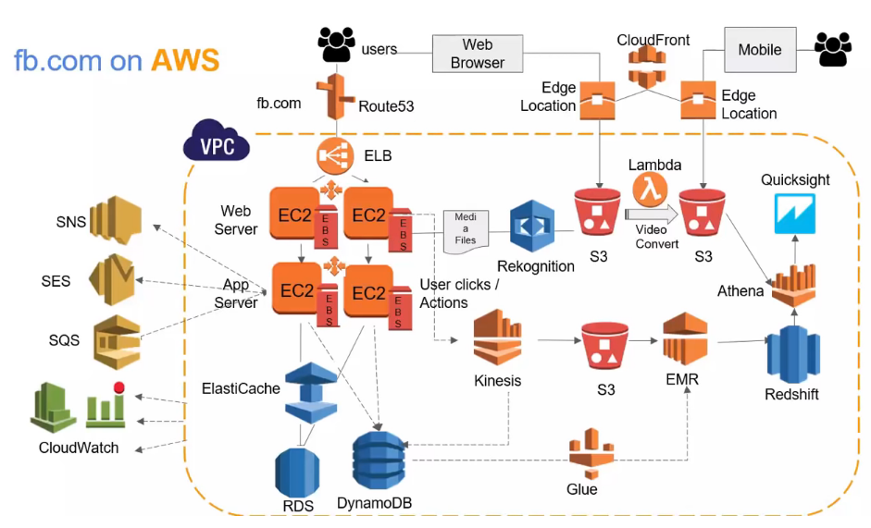

**AWS APPLICATION SERVICES**

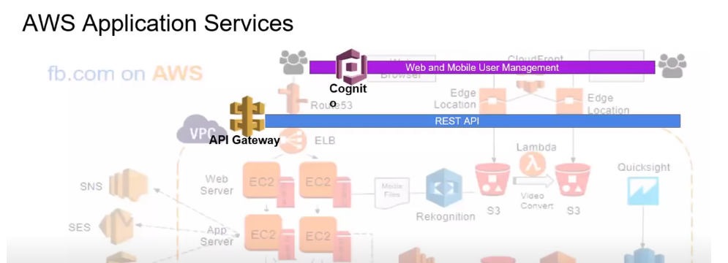

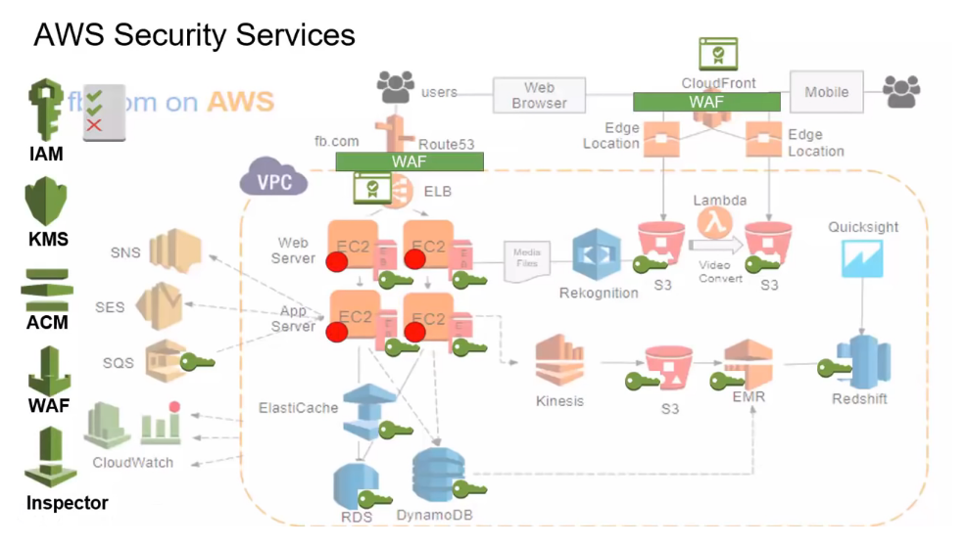

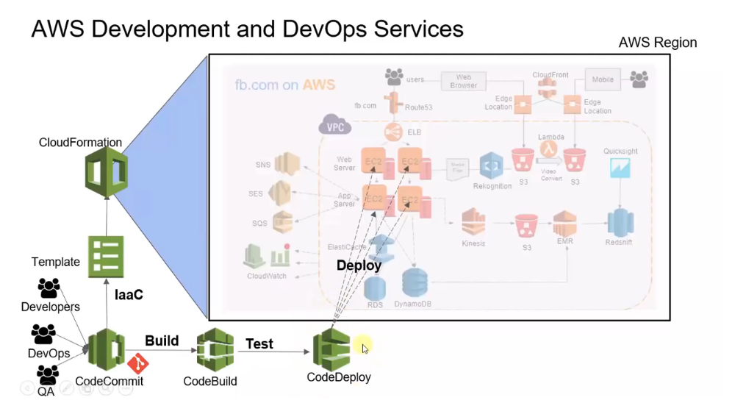

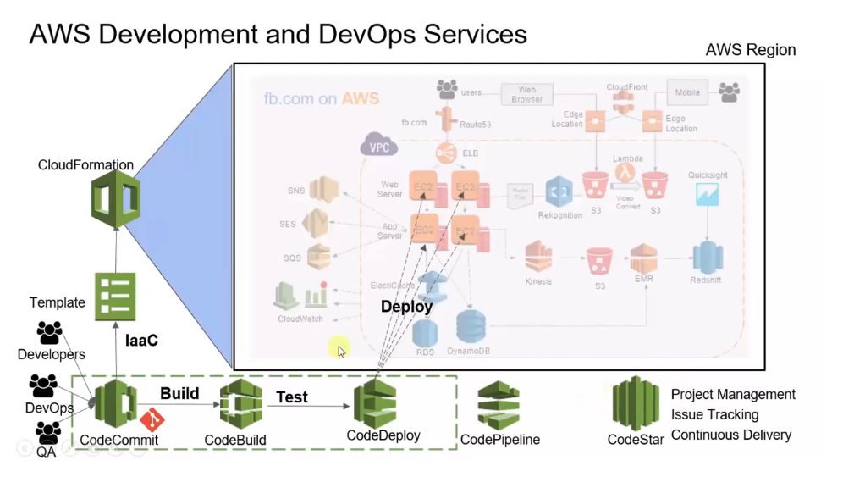

**Aws NETWORKING BASICS**

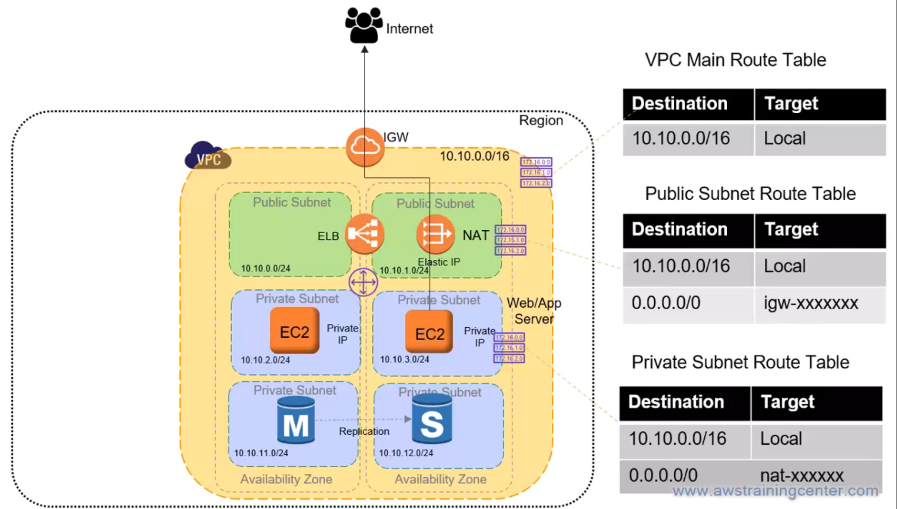

**In**  aws sometimes we need to connect our vpn to the aws vpn so we have two ways of doing so

One way is to have a direct vpc to vpc connect in which there will be a customer gateway at the client side and a virtual gateway at the aws side and the connection will be private an d the data moves from one place to the other ina asecur emannner.and it will be suing the ipsec policy to route the traffic.

Another way is to use the aws direct cponnect .Aws direct connect has a direct connection to the aws vpc and the companies who want to connect to aws will register themselves on the aws direct connect.

**REMOTE WORKER TO VPC**

In the covid times we needed to connect to the company network from our own network so we had to connect to the vpn. So in case of aws we have a client vpn endpoint which will help us connect to the aws region.

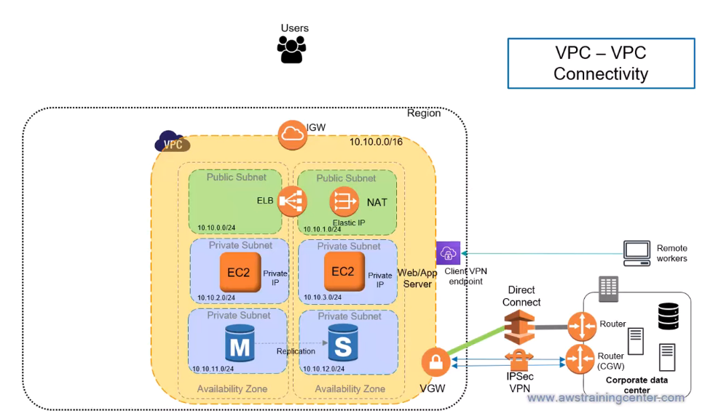

**VPC PEERING**

A vpc peering help us to connect two vpcs so that vpcs can talk to each other.

But if we want to coonect many vpcs together then we need to have a different connection to different vpcs.

Now suppose when we want to interconnect too many vpcs then it is too much difficult to connect them so aws has come up with a new approach of a transit gateway.

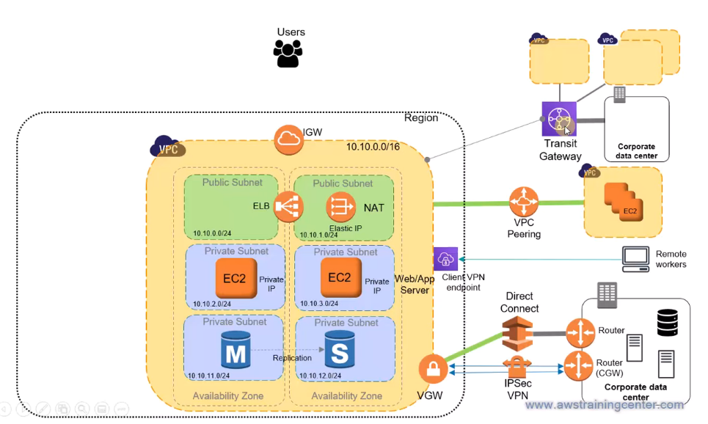

**VPC ENDPOINT SERVICES**

We use the vpc endpoint services in case if we want that we need to connect to smem aws service in our region only.

So suppose an ec2 instance in a private subnet needs to access some data from the s3 bucket which is public facing so we need to go through the nat and then the internet gateway and then we will be able to access the s3.

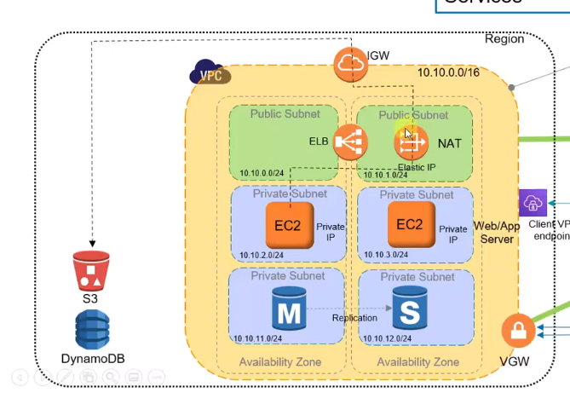

So if we follow the above archiotecture then we need to depend on nat and also the internet gateway.so if for some reason the nat or internet gateway is down then there will be an issue.

So to solve this problem a vpc endpoint concept was Introduced so that our service in the private subnet can directly access the s3.

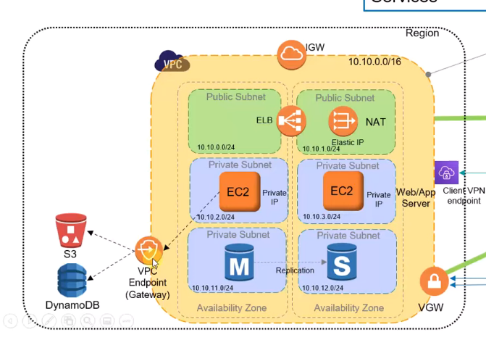

There are two flavours of the pc endpoint

1.vpc endpoint gateway

Which is used by our aws private network services to accesss the other aws services without the need of an interface.

2.Vpc endpoint interface:this is used in case our private resources want to access the aws services such as s sqs,sns,cloudwatch then they can be connected privately through the vpc endpoint interface.

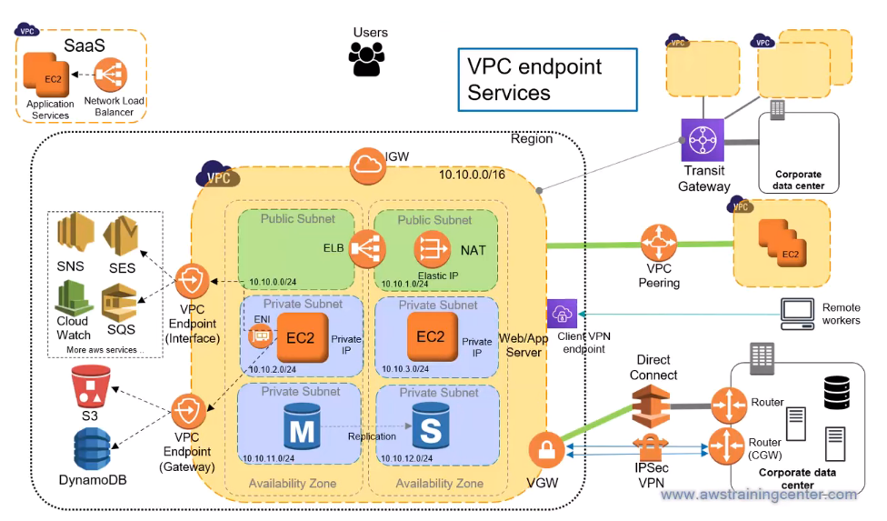

**VPC PRIVATE LINK**

Suppose we have a saas service which is present in a vpc.Now this will have a private link so that only one of its service is available to the outside world.Now w e do not want to show them all our services.Though we can do it with vpc peering but not possible since it will show out all the services to the other vpc.

